- MONKEY BANANA PROBLEM
AIM
To write a Prolog program to implement the Monkey and Banana problem using facts and rules.
OBJECTIVE
- To represent the monkey, chair, and banana as facts.
- To use Prolog rules to solve the problem.
- To determine whether the monkey can obtain the banana.
- To understand knowledge representation and logical reasoning.
ALGORITHM
- Start.
- Define the positions of the monkey, chair, and banana.
- Create a rule can_get_banana.
- Check whether the required objects are present.
- If the conditions are satisfied, perform the actions: move chair, climb, and get banana.
- Display that the banana is obtained.
- Stop.
FLOWCHART
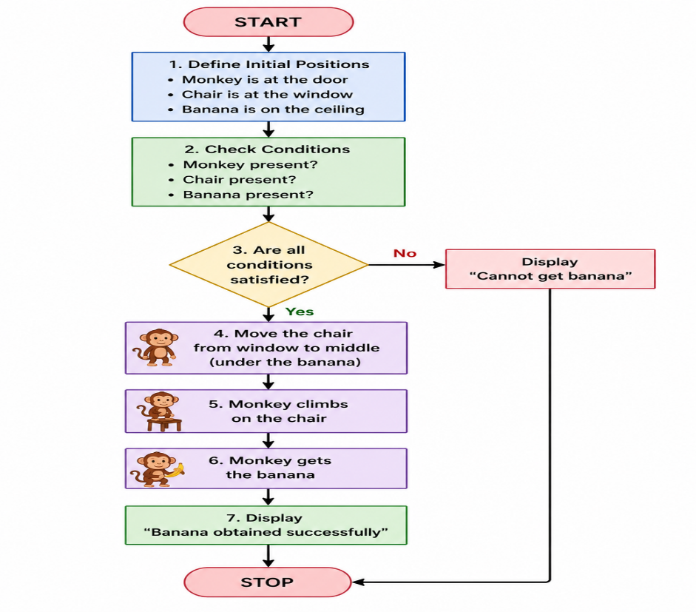
CODE
monkey(at_door).
chair(at_window).
banana(on_ceiling).
can_get_banana :-
monkey(at_door),
chair(at_window),
banana(on_ceiling),
write('Monkey moves chair, climbs and gets banana.').
OUTPUT
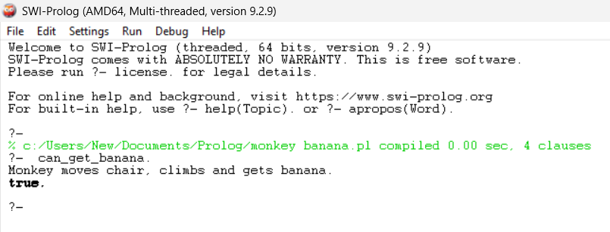
RESULT
Thus, the Monkey and Banana problem was successfully implemented in Prolog, and the monkey successfully obtains the banana when the required conditions are satisfied.

